Educational Visit to Great Ormond Street Hospital, 15th-19th August 2016

With my career intention to pursue a speciality interest in craniofacial surgery, I arranged to spend a week at the Dept of Craniofacial Surgery at Great Ormond Street, to increase my exposure, see new techniques, and pick up some new ideas and inspiration along the way.

My experience is best dealt with on a day by day breakdown, as there was much to learn.

Day 1:
The case- Crouzon Pt, 16 year old, previous monobloc advancement at 18 months age. Now attends for sub-cranial Le Fort 3 and RED frame distraction.
Whilst this is a “standard” approach in Liverpool too, there were key differences. In the set-up, GOS have a written protocol which covers pre-operative care, intra-op and post op care for the duration of their stay to minimise infective risk. This extended to when to change gloves, hair washing and wound care- very thorough and clear.
Surgically they use a tumescent solution as an infiltrate with local anaesthetic and triamcinolone to reduce swelling.
They accessed the orbital floor for the osteotomy via the bicoronal flap- in Liverpool eyelid incisions are routinely used, and this is not without complication,so I was impressed to see that they could achieve the osteotomy without that incision.
Of great interest to me was the use of intra-operative navigation- this was the “stealth” system and allowed pinpoint positioning of the osteotomy cuts away from the cranial base. It really was an amazing piece of equipment, hugely reassuring to know you were safe and with no appreciable time delay to use it- definately something worth looking at for the future in all craniofacial units- the benefits were so clear.
GOS routinely use 2 nasopharyngeal tubes in craniofacial cases, to stop/reduce air being trapped intracranially when the skull base is breached. This is simple and effective, and again something I think is well worth bringing to my own practice.

Day 2:
MDT day.
Similar to AlderHey there is an extensive MDT once a week.
What I particularly liked was the presence of a sleep physician at the MDT for up to date sleep study reports and that the IT system had photos of all of the cases uploaded as well as the imaging. You could also click on the top tabs and the latest information and notes from each speciality in the MDT was there ready to be seen by the whole MDT.
A neat touch was a side bar with dates of previous surgeries, what they had done and future surgical dates already booked. Quick and easy to get to grips with these complex patients.
I also saw two facial haemangiomas resected in theatre on day 2- this was great as craniofacial have less involvement with haemangiomas in Liverpool, with them mainly being treated by plastics.

Day 3:
Theatre:
3 cases.
1: removal of spring distractors for sagittal synostosis
2: insertion of 3x spring distractors for sagittal and lambdoid synostosis- this is a technique only used at GOS in the UK, and a few other centres worldwide, for suturectomy and distraction. It is a “half way house” to full vault re-modelling and got a really nice result for the Pt with minimal blood loss. A really exciting technique.
3: Fronto-orbital remodelling for metopic craniosynostosis
This is a workhorse operation for a craniofacial unit, and GOS have their own variations on the technique.
They do not use a bandeau as was described in the original cases, but leave the fronto-nasal suture un-osteotomised. They then invert the segments and use wires and prolene to stabilise- no absorbable plates used. This resulted in a very nice head shape and a total surgical time of 150mins- very quick for an FOAR.

Day 4
Maxillofacial morning:
I took the morning to shadow Mr Ayliffe, Consultant Paediatric Maxillofacial Surgeron.
Again, there was much to see and learn.
He advocates using sheet prolene for closure of oro-nasal fistulae- he has 20 years experience of this instead of ear cartilage and says he gets great results.
He had an aggressive ossifying fibroma on his list, who he performed a segmental mandibulectomy on, and placed a free iliac hip graft (block)- he says this is very successful in children due to the hugely reparative bone and most do not need free flaps.
I also went into cleft theatre where Mr Morris was performing a UCLP. He uses plastic nasal splints for nasal moulding and holds them in place with PDS- this takes 4-8 weeks to absorb by which time the moulding is done.

Craniofacial Clinic afternoon:
This was a busy clinic filled with pre and post op craniofacial children- whilst broadly similar to Liverpool it was interesting to see the differing treatment approaches, for example use of spring distraction, and use of the GOS ethics board for difficult cases. A very interesting day.

Day 5
Day five gave me the chance to see an endoscopic resection of a forehead dermoid- this allowed very minimal incisions (important as the child was african origin therefore more likely to have keloid scarring) and a very nice dissection- the team are hoping to bring endoscopic suturectomy to the department for selected cases soon, and seeing the techniques and equipment I can certainly see the potential.

For people wishing to also spend time at GOS it is worth noting that there is a flat fee of £150 for paperwork processing independent of how long you spend at GOS- I hadn’t realised this until the process was underway so it is worth noting this for future visitors.

In summary, this was an inspiring and exciting trip, which opened my eyes to new techniques and approaches. It gave me the chance to meet a broad group of surgeons and has definately pushed me on to continue my career aspirations, and it would have not have been possible for me to achieve this without the support of the British Association of Oral and Maxillofacial Surgeons.

Summary of expenses

Hotel (see forwarded e-mail)
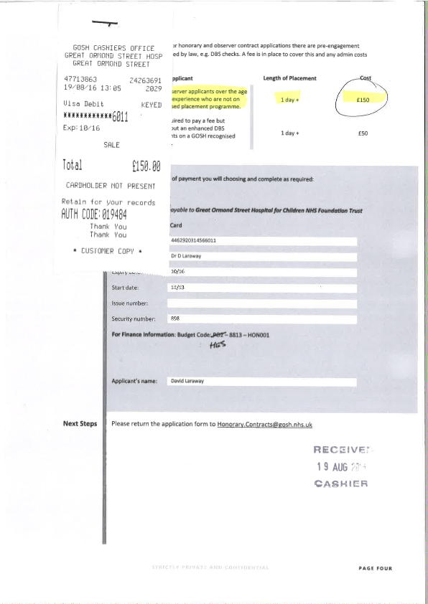
Train (see forwarded email)
Paperwork £150

